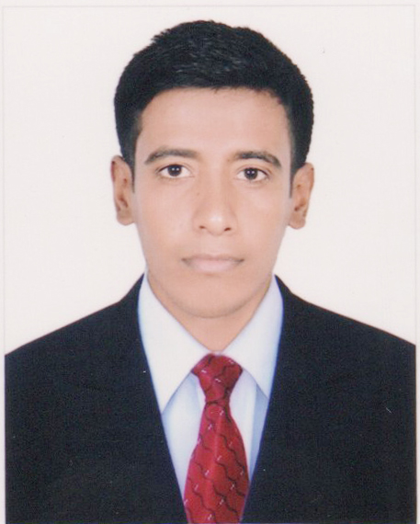
Curriculum Vitae
Of
MST. SELINA KHATUN
Mob : +88 01980554751
mamunurrashid7728@gmail.com

Career Objective:

Looking for hard and challenging job where I will have the scope to utilize my potentiality and skills to do something innovativeness utilizing and from where I will be able to enhance my knowledge.

Personal Details :

Name : Mst. Selina Khatun
Father's Name : Md. Alif Shikder
Mother's Name : Mst. Morjina Begum
Date of birth : 31 December 1995
Permanent Address : Vill.: Belgasi, Muslim Para P.O.: Chuadanga
P.S.: Chuadanga, District: Chuadanga

Present Address : Vill.: Belgasi, Muslim Para P.O.: Chuadanga
P.S.: Chuadanga, District: Chuadanga
Nationality : Bangladeshi
Religion : Islam
Marital Status : Unmarried
Sex : Female

Educational Qualification :

Higher Secondary Certificate

Institute : Adarsha Mohila College, Chuadanga
Group : Business Studies
Result : GPA-3.00
Passing year : 2014
Board : Jessore Board

Page No.- 02

Computer skill :

I have successfully completed 6 months on Computer Office Applications, MS Word, MS Excel and Photoshop & Browsing.

Language Proficiency:

Reading, Writing and speaking proficiency in Benglai & English.

Interpersonal Skills:

- Ability to work independently and can work with people of all level.
- Search for in depth and analytical ability.
- Ability to work in Group and to maintain the group.

Interest:

- Travelling, Playing, Organizing Friendship, Reading, Journals.
- Communicating with people.
- Challenging job.
- Social service & other cultural activities

Declaration of Authenticity

I Mst. Selina Khatun hereby declare that the above-furnished information is true to the best of my knowledge and belife.

Date : (Mst. Selina Khatun)

